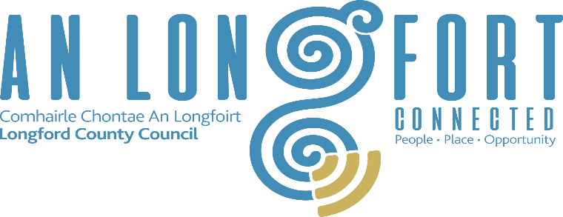

Longford County Council
Aras an Chontae, Great Water Street, Longford.
Tel: (043) 334 3300

Request for Tender (RFT)

EVENT PROGRAMMING, GENERAL MANAGEMENT AND PRODUCTION AND PROMOTION SERVICES For the SHOP LOCAL CAMPAIGN FOR CHRISTMAS 2022

For
Event Management, Programming & General Production
Procedure | OPEN
LCC Reference: | Shop Local Campaign for Christmas 2022
Issue Date | 21/10/2022
Closing Date for Queries | 26/10/2022 at 12:00 Noon
Email for Queries | mnevin@longfordcoco.ie
Closing Date / Time for receipt of Tenders | 28/10/2021 at 5:00 pm
Instructions for Return of Tenders: | Completed tender documents to be submitted via email (must be submitted in a SINGLE document, preferably in PDF format or MSWord).

1. INTRODUCTION
The Contracting Authority for the purpose of this Invitation to Tender is the Local Enterprise Office, Longford. Local Enterprise Office is in Longford County Council, Great Water Street, Longford.

You are being invited to submit a tender to Local Enterprise Office (the ‘Agency’) to carry out:
A comprehensive social media marketing campaign to promote Shop Local in Longford Christmas 2022.

2. BACKGROUND
2.1 Shop Local Campaign for Christmas 2022
Shop Local Campaign for Christmas 2022 is a social media campaign to be created, produced, deployed, managed, documented, and promoted between 4th November 2022 and 24th December 2022 (exact dates to be agreed with successful Tenderer).
The Local Enterprise Office would like to promote Longford as a destination of choice for Shopping (Online & Instore).
The campaign should showcase the wide variety of local businesses across the County and the range of products available in the locality.
3. SPECIFICATION OF REQUIREMENTS
3.1 Detailed requirements
The overarching themes for this campaign are:
- To leverage the success of Shop Longford 2021 and continue to create an awareness within the Longford community that spending locally creates more wealth and jobs for the local population.
- To position Longford as the destination of choice for shopping in the midlands (Online & Instore)
- To showcase the diversity in retail outlets (low end/high end) to encourage shopping locally
- To assist businesses in the uptake of their online sales platforms.
- To drive traffic to the existing Shop Longford Directory Listing

3.2 Responsibility of Tender
The successful Tenderer must perform the following services:

3.2.1 Programming
- The successful Tenderer must devise, promote and manage a social media campaign on all platforms such as Facebook, Twitter, Instagram, etc.

3.2.2 Marketing, Promotion and Sales:
- Production & delivery of an effective Marketing and Promotion Plan for the campaign

4. OUTPUTS REQUIRED
A social media campaign to be created, produced, managed, documented and promoted between 4th November 2022 and 24th December 2022.

5. TYPE OF CONTRACT
Service.
6. CONTRACT MANAGEMENT AND CONTRACT REQUIREMENT
The successful tender will be required to:
- Deliver the requirements outlined in Sections 3 and 4 above.
- Maintain full records including budgeting and accounting records for the contract.
- Be proactive rather than reactive.
- Work with the staff in Local Enterprise Office, Longford in the coordination of the campaign.

7. CONTRACT PRICE
Bidders should indicate prices for a range of services (as outlined in Section 3). Costs should be clearly broken down to reflect the different elements of the methodology you propose, including any additional data collection as suggested.

8. PAYMENT ARRANGEMENTS
Payment will be made on receipt of invoices.

9. AWARD CRITERIA
The award criteria for this requirement is the most economically advantageous tender evaluated against the following criteria.
Criteria | Marks
- Relevant Experience | 25 Marks
- Understanding of the requirements | 25 Marks
- Resource Availability/Knowledge of systems | 35 Marks
- Price | 15 Marks

Bidders may be short-listed and required to meet with the Local Authority to discuss their approach, experience and other capabilities with an assessment panel. Should this be the case the Agency will use the criteria as stated above to revisit the original scores following clarifications and presentations.

10. QUERIES
All queries in connection with this tender should be made through email to mnevin@longfordcoco.ie

To ensure a fair and transparent tender process no approach of any kind in connection with this tender should be made to any other person within, or associated with, Longford County Council. Failure to comply may result in disqualification from the process.

11. TENDER RETURN
The completed Tender and associated documents must be submitted via email by no later than 5pm on 28th October 2022.

End of Document

